|  |  |
| --- | --- |
| Book E-Rental Store (BERS) | Version 1.0 |
| Software Requirements Specification | 15th Jun 2016 |
| Rumours | |

Rumours

**Book E-Rental Store**

**Software Requirements Specification**

Version 1.1

**Team Guide: Mr. Mudit Khetan & Mr. Navneet Verma**

**Members: Kishan Kumar**

**College Name: Jaipur National University**

**Department: Computer Science**

**State: Jaipur**

|  |  |
| --- | --- |
| Book E-Rental Store (BERS) | Version 1.0 |
| Software Requirements Specification | 15th Jun 2016 |
| Rumours | |

**Revision History**

|  |  |  |  |
| --- | --- | --- | --- |
| **Date** | **Version** | **Description** | **Author** |
| 15th Jun 2016 | 1.0 | Synopsis | Rumours |
| 15th Aug 2016 | 1.1 | Synopsis | Rumours |
|  |  |  |  |

**Acknowledgement**

**I would like to thanks my Associate Professor Mr. Mudit Khetan and my Asst. Director Mr. Navneet Verma who continuously guide me during the whole course of my project. I would also like to thank my friend Abhijit for his assistance and insightful comments and who willing to share his experience with me.**

**I sincerely acknowledge and thank my family members and friends who gave moral support for me from my childhood.**

**Abstract**

All book lovers want to read as many books as they can lay their hands on, but most of them either cannot afford them to buy, or do not have a proper home space to store them, or simply do not have options to first read the book and then decide to buy them. If a library provides them the facility to browse and loan the books/magazines of their choice, then certainly they would be able to read more books and many would end up buying them. The library system has an inherent problem that it is not self-sustaining and always has paucity of funds due to its dependence on donors and grants. Similarly, the donors and funding agencies impose their choice on the librarians to only offer those books and magazines which they deem “fit” for the readers. The popular choice of the readers and current/latest books are mostly not available in such libraries, barring a few exceptions.

If a library works on the principle of self-sustainability by earning from the loaned books, it can better suit the needs of the readers and can grow over a period of time. That is where the concept of BERS comes into play.

The main objective of the project is to create an online book/magazine (referred to herein as books) rental store that allows users to search and rent them online, after becoming members. The books catalogued and indexed on many filters (like title, author, category, genre, etc.) and allow filtering based on these. The website would be aesthetically pleasant and easy to use for the targeted users. The rental store would take security deposits from members that can be deposited through online payment facility. Using this Website, the user can rent a book online instead of going out to a library/stores and wasting time in browsing the book.

There are many online book stores like Powell’s, Amazon. I want to develop a similar website using JavaEE and Oracle 10g.

This application is developed using JavaEE programming language. The Master page, data sets, data grids, user controls are used to develop the Online Book E-Rental store.

**Table of Contents**

**Description Page No.**

1. **Introduction**

1.1 Purpose

1.2 Scope 1.3 Definition, Acronyms, and Abbreviations 1.4 References 1.5 Technologies to be used. 1.6 Overview

**2.0 Overall Description**

2.1 Product Perspective

2.2 Software Interface

2.3 Hardware Interface

2.4 Product Function

2.5 User Characteristics

2.6 Constraints

2.7 Architecture Design

2.8 Use Case Model Description

2.9 Class Diagram Sequence Diagrams

2.10 Database Design

2.11.1 ER Diagram 2.11.2 Schema 2.12 Assumptions and Dependencies

**Software Requirements Specification**

1. **Introduction**
   1. **Purpose**

The Main objective of the project is to create an online book store for the Users who are willing to read the book but they cannot buy that book for them we are providing them a rent facility which makes their Burdon less. Book Store allow user to search the books on Basis of Different Category market like fiction, science, technology, romance etc.

* 1. **Scope**

The software system being produced is called Book E-Rental Store. It is being produced for the customers interested in getting book’s on rent via the Internet. This System is designed to “Provide Automation Support” for placing book for rent on the Internet and Facilating the actual Sale. This System is largely cross-platform and is available to anyone On Internet. This System will be run on a central server with user having a remote user interface through a web browser to interact with it.

* There are three basic users – Anonymous(Guest), Registered Members(customers), Library Staffs, Administrator
* The customer, through the process of account creation, will have the option to Become a member of the site.
* The system will allow customers to browse, search, select, and add books to a rental cart.
* Admin/Sr. Librarian has the authority to add/delete users, grant permission to members/Staff and users to rent book and in return is also responsible for generating mobile message for customers regarding book rental transaction and delivery.
* Pick up Facility and The Online Transaction Facility Where will be provided to our customers.
* We Are providing additional facility to our customers who are interested in Magazines and Newspaper Can Rent It.
  1. **Definition, Acronyms and Abbreviations**
* **Admin -:** He has authority to add/delete users, grant permission to Staffs and can add/delete books and he/she can change the Database Model etc.
* **Sr. Librarian-:** He has Authority to Add/Delete users, grant permissions to staff, can generate reports, Add/Delete Users, Bill generation etc.
* **Java -:** Java language is intended to be simple,modern, general purpose, Object-oriented programming language.
* **Oracle 10g -:** Oracle 10g is a relational database server, is a software product whose primary function is to store and retrieve data as requested by other software applications.
* **HTML -:** It is a Hypertext Markup Language used to design client side static web pages.
* **CSS -: Cascading Style Sheets** is Used for managing and formatting layout of HTML web pages.
* **HTTPS -: Secured Hypertext Transfer Protocol: It’s** a service protocol.References
  1. **References**
* IBM (SRS Sample)
* Amazon.in (Book Views)
* Google Book
* Different Online Book Stores/Rental Sites
* Database Management Systems - korth.
* IBM – [www.ibm.in/developerworks](http://www.ibm.in/developerworks).
  1. **Technologies**

**Programming languages:**

* **Java:** Java is intended to be a simple, modern**,** general purpose, object oriented programming language. The language, and implementation thereof, should provide support for software engineering principle such as strong type checking, array bounds checking, detection of attempts to use non-initialized variables, and Garbage Collector.

Software robustness, durability, and programmer productivity are important. The language is intended for use in developing software components suitable for deployment in distributed environments in intended to be suitable for writing applications for both hosted and embedded systems, ranging from the very large that use sophisticated operating systems, down to the very small having dedicated functions.

* **HTML, XML:** Hypertext Markup Language and Extensible Markup Language are the predominant markup language for web pages. It provides a meaning to describe the structure of text-based information in a document and to supplement that text
* **Back End- Oracle 10g:** Oracle 10g is a relational database, developed by oracle. It is a software product whose primary function is to do CRUD Operation on data as requested by other software operations, be it those on the same computer or those running on another computer across a network (including Internet).
* **Operating System-Windows /Linux-:** Operating System is the Most important part in our development because deployment of server and application is done on it only and basic network security will be provided by the operating system and many of our work is handled by operating system which make our development easier.
  1. **Overview**

**Existing System-:**

* Manually Registration
* Abstraction in Online Book ‘s Rental Stores.

**Drawbacks:**

* No Webcam Support

**Proposed System:**

* Registration for members.
* Online maintenance of Book and sales.

**Our Plan:**

* Acknowledgment for Registration, sales and Arrival of New Books.
* Feedback from Users.
* New Users Registration.
* Providing Free E Magazines to All Users Including Anonymous Users.
* Notification On User Dashboard of Their Rent and Books status.

1. **Overall Description:**
   1. **Product Perspective:**

Host/Client

Server

BERS is an online bookstore website which support a number of functions for both the consumers and store’s management.

The Website must be available to anyone using the Internet and as such must work correctly in Mozilla, Chrome, Internet Explorer. As stated by the customer, there are no hardware or software requirements beyond these including, but not limited to memory or specific software package that need to be utilized nor software packages that need not to be utilized.

* 1. **Software Interface:**
* **Client on Internet**
  + Web Browser, Operating System
* **Web Server**
  + Apache Tomcat, Glassfish
* **Database Server**
  + Oracle 10g
* **Development IDE**
  + NetBeans (8.1)
  1. **Hardware Interface**
     1. **Recommended Requirements:**

|  |
| --- |
| **Computer Needed With The Browser Support** |

|  |  |  |  |
| --- | --- | --- | --- |
| **SERVER SIDE** | | | |
|  | **Processor** | **RAM** | **Disk Space** |
| **Oracle10g** | **Intel I3** | **500MB** | **2GB +User Data** |
| **Apache Server Service And Third Party Packages** | **Intel I3** | **2 GB** | **3 GB** |

* 1. **Product Function:**

E-Book Rental System will help to know automatically when certain book requested by them has arrived and their rental due dates once they register with the organization.

Some of the features of the product are as followed:

* Main data Associated with the inventory
  + A book has a Title, Author, ISBN and Price etc.
  + The Inventory also keep track of stock/quantity of each book.
* Maintain Records of the users.
  + A user can be either a member or staff.
  + A Customer has a Username (Unique across all User), Password (Condition), Email, address, Postal code, Cell No., Etc.
  + Anyone may sign up to become a member.
* Allow Any Authenticated User to Become a Member.
* Show a listing of available Books
  + Books are to Be Displayed in Ascending Order Alphabetical order as Per Search.
  + Each Book will list the following from left to right
    - Title
    - Author
    - Price, Etc.
* Allow User’s to login and logout of the System
  + Users will Be logged out if inactive for 30 Minutes.
* Rental Cart
  + Registered(Customers) User’s is able to add one or more books to the rental cart.
    - The Rental cart does not allow multiple copies of any Book.
* User Can discard any items from cart before final Transaction.
* Checking Out
  + Checkout is Only Available to registered users. A user that is not logged in as a user is given a chance to log in.
  + Online Transaction Facility Is Provided
    - Collect The Card Number and CVV Code.
* Log/Record of Every Transaction is Maintained
* Pick Up Facility Is Only Provided for Any Rental Transaction.
* Allow Staff to stop any User Rental Order and Notify Him/her
  + Each Book has its own stop-order status, before packing if book condition is Bad and no Other Book is available in stock then staff can stop the order and update it as disposal.
* Notify Staffs when book need to be reordered
  + When the quantity of a book falls below a threshold, the staff is notified that the book needs to be reordered.
* Allow staff to update the stock of book
  + Allow staffs to change any book’s price.
  + Allow staffs to view transactions log.
  + Allow Staffs to View and Generate Reports and receipts.
* One Exception is if staff has already specified a stop-order for the book.
  + Every Book Must either have stop-order enable or disable.
* Allow Administrator to generate Notifications for the users.
* It will ease and speed up the planning decision making process, secure confidential and reliable reports
* It automated the system with the help of Email that informs the user about the availability, price and method of purchasing the book.
* It mainly emphasized creation and implementation of a book sales management information system.
* It focused on the acquisition, distribution and management of books.  
  1. **User Characteristics:**
* **Guest/Anonymous:** Non Members can visit us and can access free services.
* **Members:** Register Members can access all the functionalities provided on websites. Registered Member have their own profiles.
* **Staff:** The staffs are divided into 2 category
  + **Jr. Librarian:** Have Authority to control transactions and can add/delete the Books Details Can Fine Any Member for Violation of rules, prepare the delivery packets to be picked up by Members.
  + **Sr. Library:** Have Authority to control transactions and can add/delete the books/Users detail can Fine Any Member for Violation of Rules, maintain pickup Facility, Can Change Business Rule, Can View User Profiles ETC.
* **Administrator:** All Facility of Staffs and Members are available to Admin and it have authority to Change Anyone Password by entering Essential Credentials, Can Modify the Database Model ETC.
  1. **Constraints:**
* The information of all users must be stored in a database that is accessible by the administrator.
* Book E-Rental Store is running all 24 hours a Day but for Returning and Pickup Timing is fixed.
  + **Timing:**
    - **Pickup: 8:00 Am to 8:00PM**
    - **Returning: 8:00 Am to 9:00 Am and 4:30 Pm to 5:30 PM**
* The User can Access Book E-Rental Store from any Computer that has Internet browsing Capability and an Internet Connectivity.
  1. **Architecture Diagram:**

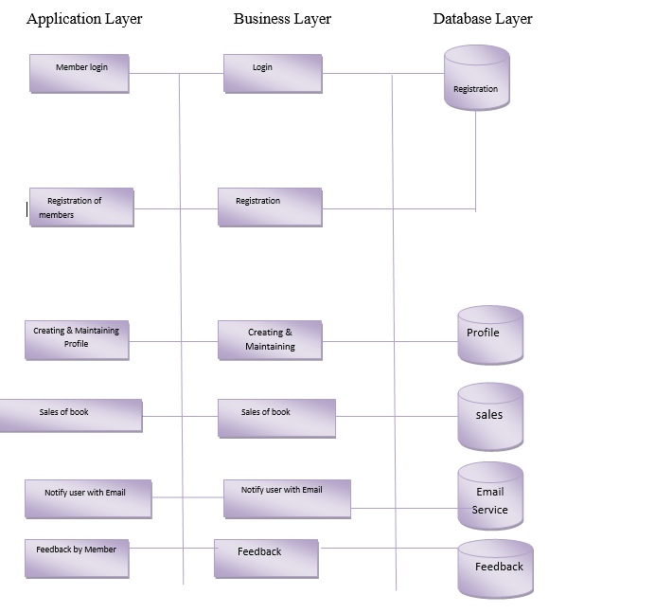

* 1. **Use Case Description:**

Use Case were designed for Object Oriented Software development they focus on what the user need to do with the system. This approach is more powerful as compared to traditional approach. It used a combination of text and pictures in order to improve the understanding of requirements. The Use Case describes what of a system and not how of a system. They only give the functional view of the System.

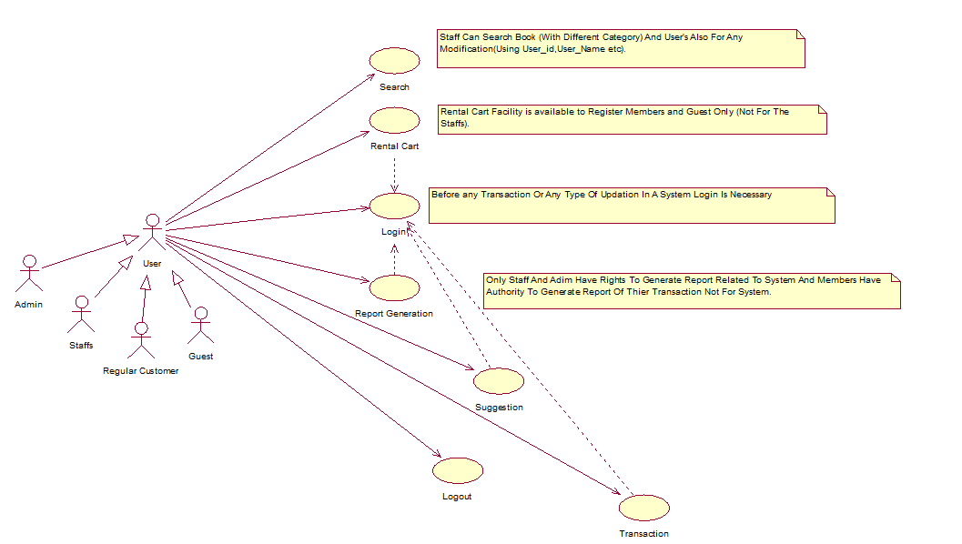

* 1. **Class Diagram:**

Note -: Class Diagram Is Under Modification So It Will Be Attached Shortly.

Due To Restful web-Services Addition

* 1. **Sequence Diagram**
     1. **Login**

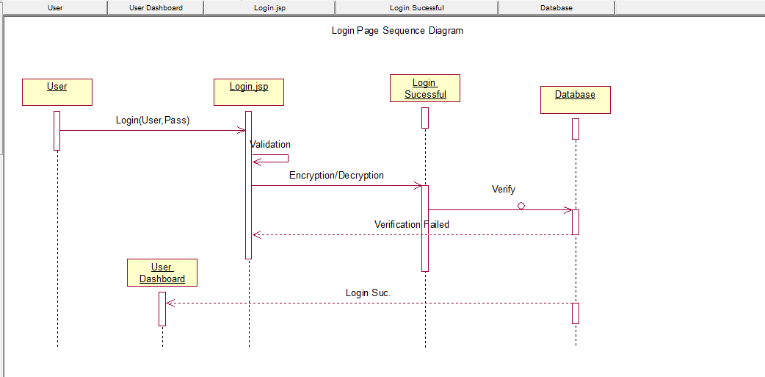

* + 1. **Logout**

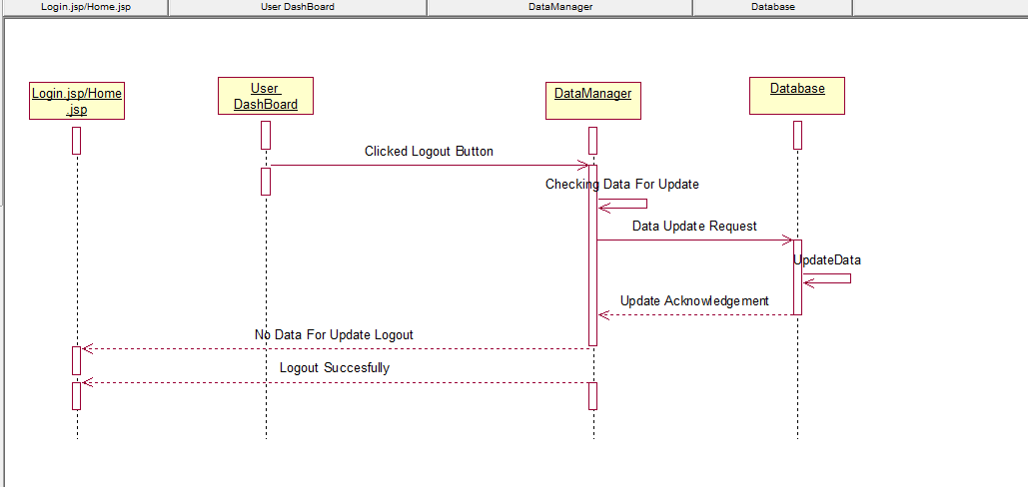

* + 1. **Registration**

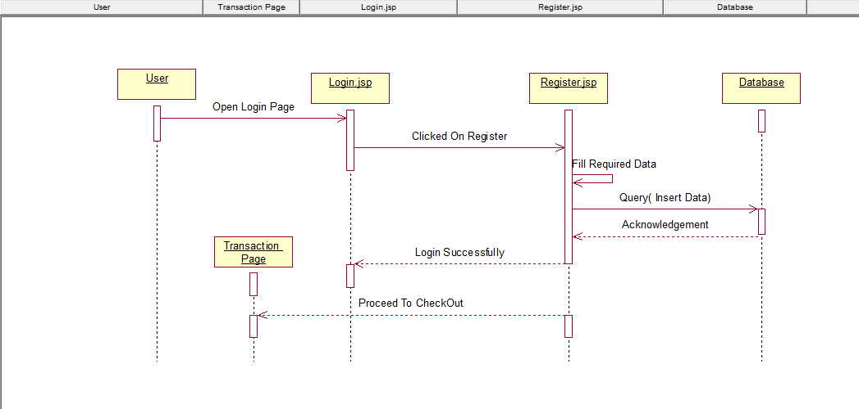

* + 1. **Transaction**

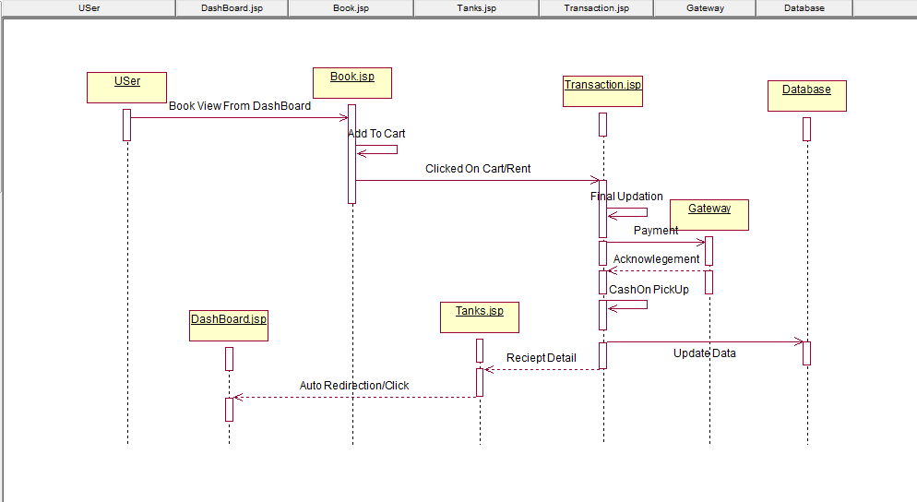

* + 1. **Notification**

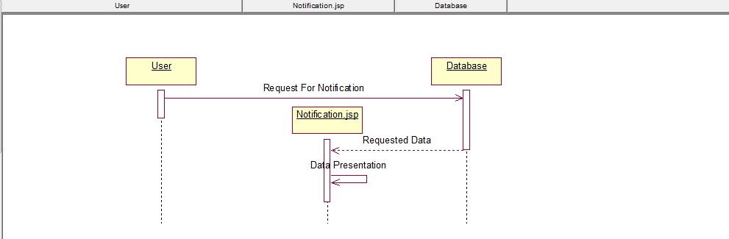

* + 1. **Report Generation**

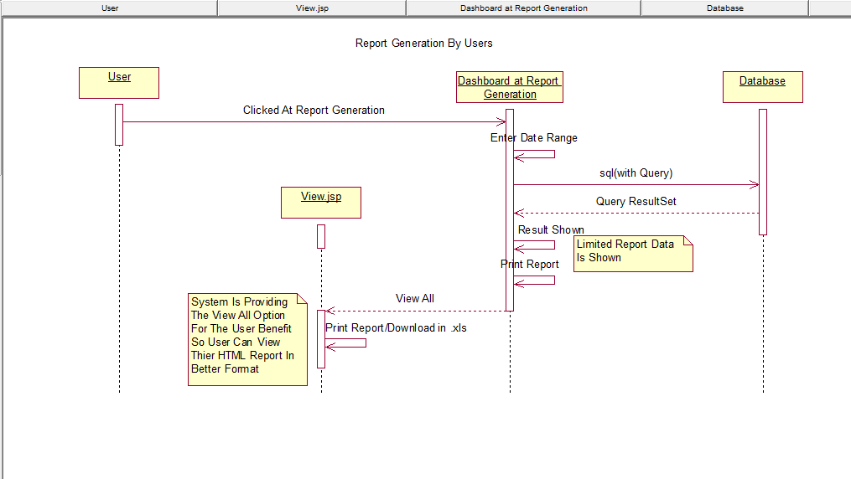

* + 1. **Book Search**

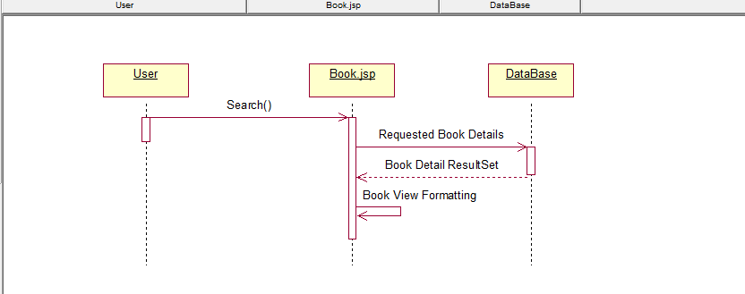

* + 1. **Book/User Adding/Modification-:**
    2. **Book/User Deletion**

**Note -: Above 2 Category Will Be Added Shortly with Small Modification.**

* 1. **Database Design**
     1. **Entity Relational Diagram-:**

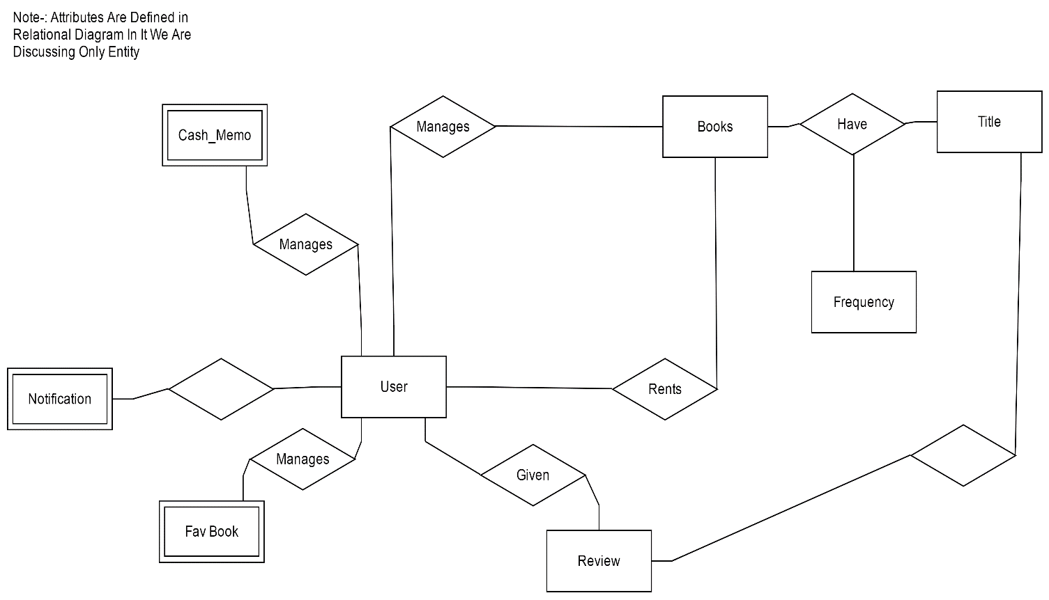

* + 1. **Relational Schema-:**

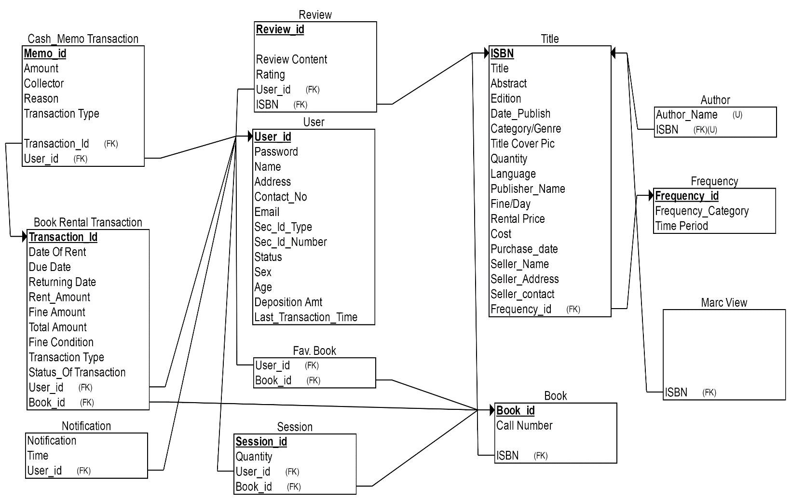

Note: Modification Can Be Happen As Per Requirement Changes So Before Final Completion The Data May Changes.

* 1. **Assumption and Dependency-:**
     1. Client:

We have assumed that all of the computer systems in the Engineering building labs are in proper working condition and that the user is capable of operating these system's basic functions including but not limited to being able to power on the system, login and open either Internet Explorer or Mozilla Firefox, and navigate the browser to the address of this BERS website.

Provider:

We have assumed that the BERS will be running on a properly working web server and database system with an Internet connection that allows this system to perform all communications with clients.

Assumptions:

* There is no need for anyone to be able to order more than a single copy of a book (or any item) in a single transaction.
* The manager account’s username and password maybe hard coded.
* The manager cannot be a customer.
* Any user cannot edit their account information. (Basic Modification Provided).

**Remark -:**

**Signature of Guide 1-: Signature of Guide 2-:**